|  |  |
| --- | --- |
| # | Release Features |
| 1 | Revised POC in Final Service Period |
| 2 | PFM Forecast Program |
| 3 | PFM Forecast Demand Odata |

1. Revised POC in Final Service Period

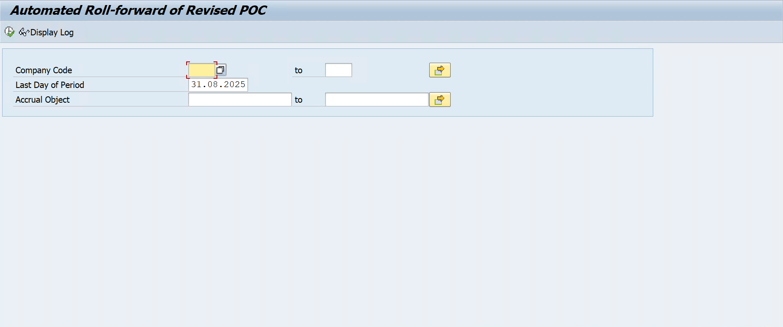

1. PFM Forecast Program

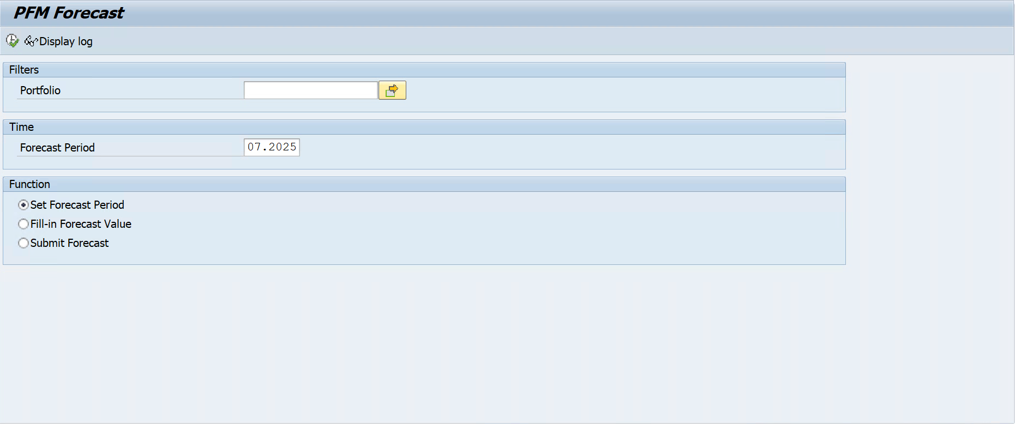

1. PFM Forecast Demand Odata

